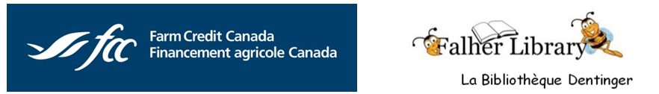

BiblioTech en français

Project Wrap-up and Highlights

This project is now complete, and highlights are attached. This was made possible by the generous funding provided by the Farm Credit Canada (FCC) Expression Fund in 2018.

We are a BiblioTECH that encourages patrons to explore Library e-Resources, and having written documentation in French in place pre-COVID provided better support for francophone populations (in our region, and throughout the Peace Library System), and helped them to navigate the use of online library resources, especially in 2020, when public libraries were unable to offer access to any physical resources for several months.

The tab below takes you this information, which is one lasting legacy of this project.



**en français**

The Board, and our staff, remain committed to offering bilingual resources and programming to support our communities, in cooperation with other community groups.

For now, programming remains virtual to protect our staff, you and the community; but we are all looking forward to when we can safely gather together again.

The photos of the Falher 100 celebration, and the Children’s Corner, awaiting families to be able to return to enjoy reading and programs together are reminders of great times we’ve enjoyed in the past in the library, with the promise of making new memories post-COVID.

Finally, thank you to our staff, volunteers, and also to all of the project partners, community groups, and sponsors who also joined with us and FCC to support this project; which leaves a legacy of enhanced bilingual public library services in our region:

Dion Computer Sales & Service

Smoky River Regional Economic Development

Société historique et généologique de Smoky River

The Friends of the Falher Library Society

The Town of Falher (1919-2019 – 100th Anniversary)

Villa Beausejour

From the Falher Regional Intermunicipal Library Board – March, 2021

|  |  |
| --- | --- |
| Translation and Sharing of e-Resource Documents | |
|  | The fall of 2019 issue of News & Notes, included the following article highlighting the french e-resource brochures available for the information of ALL libraries that are members of the Peace Library System, thanks to FCC’s support for this project.  *The Peace Library System serves 46 member libraries in northwest Alberta, in 39 municipalities, with a combined 2019 population of 174,714.* |
|  | |

Below is a link to our website, with the final complement of 8 brochures.

*(posted with our french information services brochure – previously translated by community volunteers)*

<https://falherlibrary.ab.ca/Using-the-Library/BiblioTECH>

*Clicking on each thumbnail takes you to the French version of each e-Resource brochure.*

*Sample for Press Reader below.*

*Printed versions of these are available for patrons to pick up (when we are open to the public), or to request (by mail or curbside pickup if needed).*

**Brochures en français**

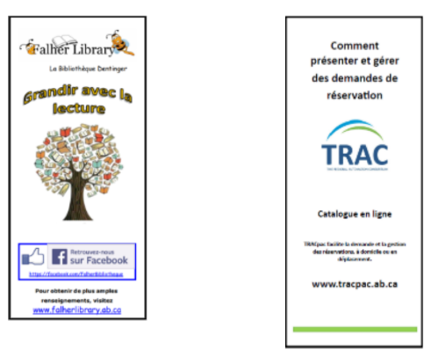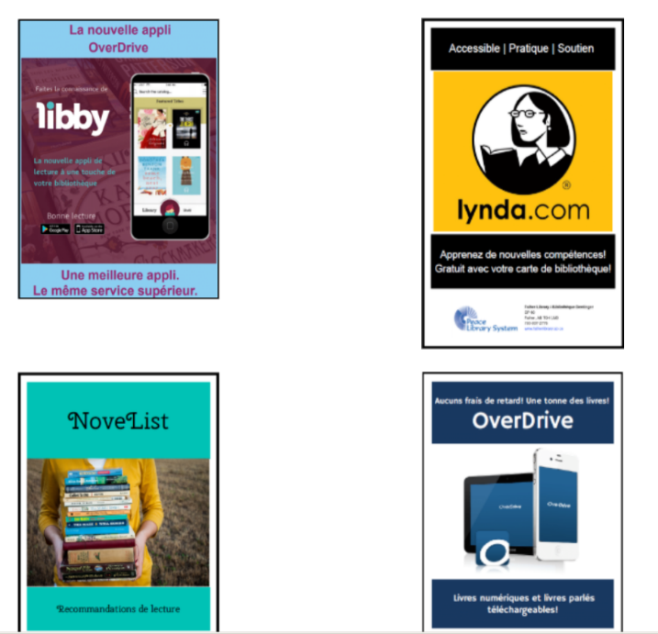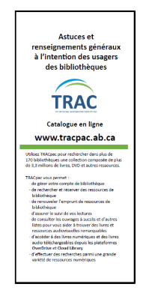

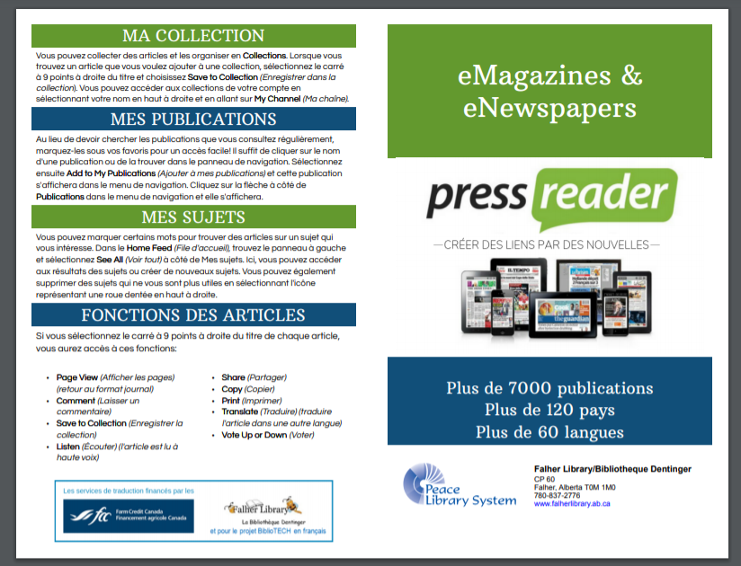

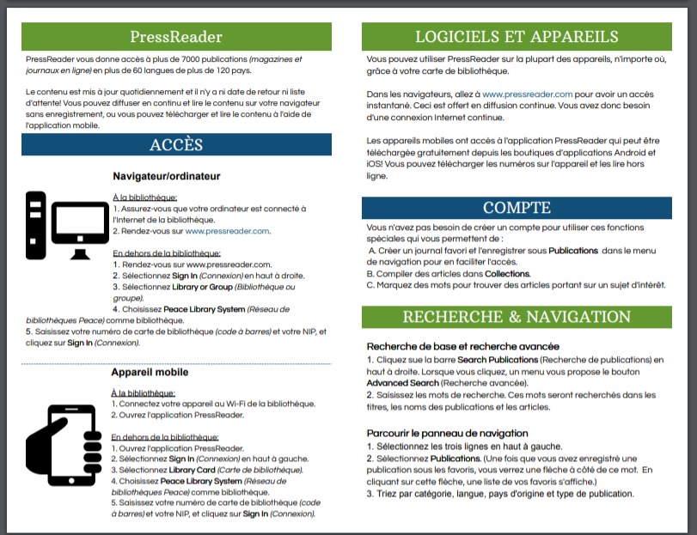

*Printed double-sided on 8.5” x 11”, in colour, and folded for ease of use*

|  |  |  |
| --- | --- | --- |
| Francophone-based Programming & Outreach | | |
| Unfortunately, this event had to be cancelled due to weather. | But, we were able to offer a second francophone family movie that was well attended. |  |
|  | C:\Users\Jackie\Desktop\FCC EXPRESSIONS\FCC Expressions Publicity\IMG_1082.jpg  C:\Users\Jackie\Desktop\FCC EXPRESSIONS\FCC Expressions Publicity\IMG_1090.jpg | C:\Users\Jackie\Desktop\FCC EXPRESSIONS\FCC Expressions Publicity\IMG_1084.jpg  This program continued after the summer trial, and is now a weekly library program offered  every Tuesday (2-3 pm).  *Photo shows our staff*  *(Thérèse) using the laptop, which FCC funded as part of this project.* |
|  | **Honey Fest and Falher’s Centennial an exciting show from start to finish**  June 25, 2019 · by [Admin2015](https://smokyriverexpress.com/author/admin2015/) ·  ***Tom Henihan Express Staff***  Falher’s 100 anniversary celebrations and its annual Honey Fest got off to an auspicious beginning at the opening ceremonies at the Centre Chevaliers on June 14.  However, other events related to the centennial celebration took place on Thursday June 13 including a collaborative project between Falher Public Library and Society Genealogique called “100 Years of History,” that presented archival material at a Library open house. | |
| ***See the next page for photos*** |  | |
| E:\HISTORY & PIX\2019 PIX\100_3318.JPG |  | |
|  | Made possible by support from:  C:\Users\Jackie\Desktop\FCC Expressions Publicity\image001.jpg    The project funded the popular photo booth backdrop (upper left), copies of printed handouts, refreshments and library staffing for this francophone-focused event. | |
|  |  |  |

|  |  |
| --- | --- |
| Online Community Event Calendar | |
| This was developed with a local vendor (Dion Computers), and was launched with a pilot group in September, 2018. It was moved to a new platform in 2020 thanks to the support of Smoky River Regional Economic Development, as a free platform for all community groups to advertise their events:  <https://play.smokyriverregion.ca/fr/calendrier>  We had hoped to expand this to include community sporting groups, in 2020, but with COVID, this is on indefinite hold. |  |
| Pre-school French Literacy Resources | |
| Finally, this new bilingual alphabet rug was purchased with the remaining project funds.  Our youngest patrons love to play with toys, or sit on the floor and read books, while waiting for their parents or siblings to look for items to take home. This rug serves as a fun, inviting way for all to learn.  The rugs also due double duty, as a favourite warm & comfy seating spot to enjoy family movie nights at the library! | C:\Users\Jackie\Desktop\FCC EXPRESSIONS\FCC Expressions Invoices\IMG_0879.JPG |