Exam Proctor Request Form
Exams may be written on Wednesday – Thursdays between 8:45 AM and 11:45 am, depending on the availability of the Proctor and scheduling of other library programs. Contact the Falher Library Career Resource Centre (CRC) at 780-837-8009 or email crc@falherlibrary.ab.ca at least TWO WEEKS before your expected exam date to book an appointment. Last minute requests cannot be accommodated.
Student Contact Information

Name: _________________________________________

Address: _________________________________________

Email: _________________________________________

Phone: _________________________________________

Exam Will be Issued By:

Institution Name: _________________________________________________

Contact Person: _________________________________________________

Email: _________________________________________________

Phone: _________________________________________________

Exam Information:

Exam Date requested: ____________________________________

Time allowed to complete: ______________________ (max. 3 hours)

Exam format: (written / online) ____________________________________

If Online: Library public computer (recommended) or personal computer use requested.
Use of your personal device must be pre-approved by the institution.
Wireless users are responsible for the setup and configuration of their own equipment, prior to exam day. Library staff cannot assist in setting up laptops to connect to the Library’s wireless network.

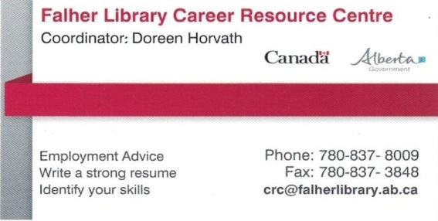
For Library Use Only:
Scheduling Confirmed
Date Request Received ________________ | Client Signature  (confirming exam request)
Date Client Notified ________________
Exam Date | Exam Day
Exam Start Time | Start Time
Exam Length | End Time
Exam Proctor Fee Payable Upon Confirmation: | Exam Status:
This is based on scheduled exam length, and is due when the exam is booked; the proctor will also require photo id.  Amount ____________________  Date Paid ____________________  Payment Method Cash / Cheque  Receipt Issued, if requested _______ | Exam completed, results forwarded ______  Exam not completed, institution notified ______  Exams must begin within 15 minutes of the exam start time, or the exam will be cancelled, without refund.  Exam reschedule date, if applicable ___________

